Viraj Bhadange
Practical exam
Q1
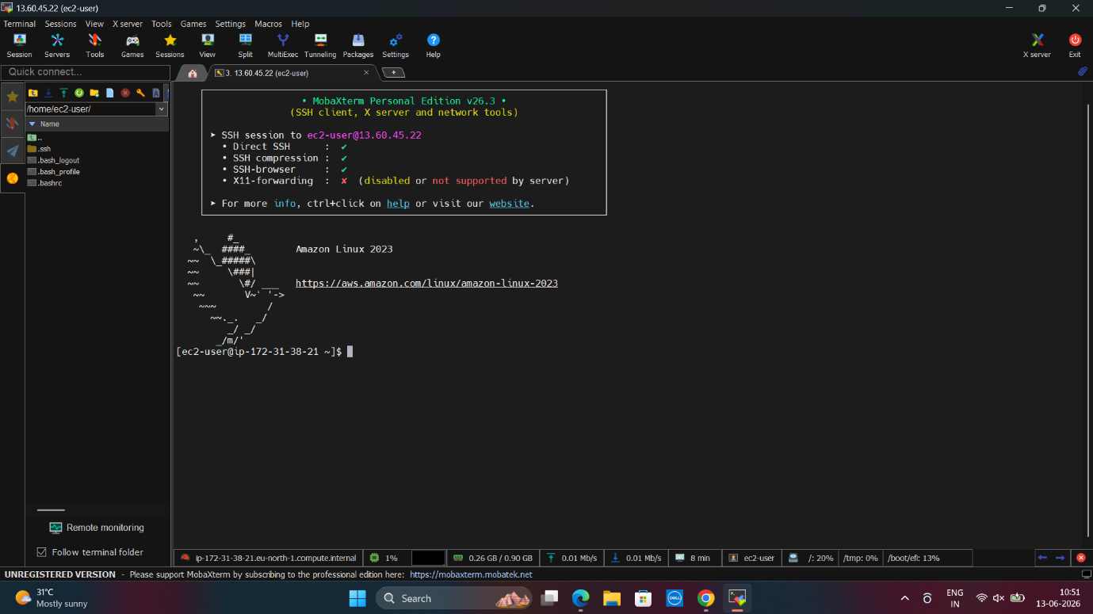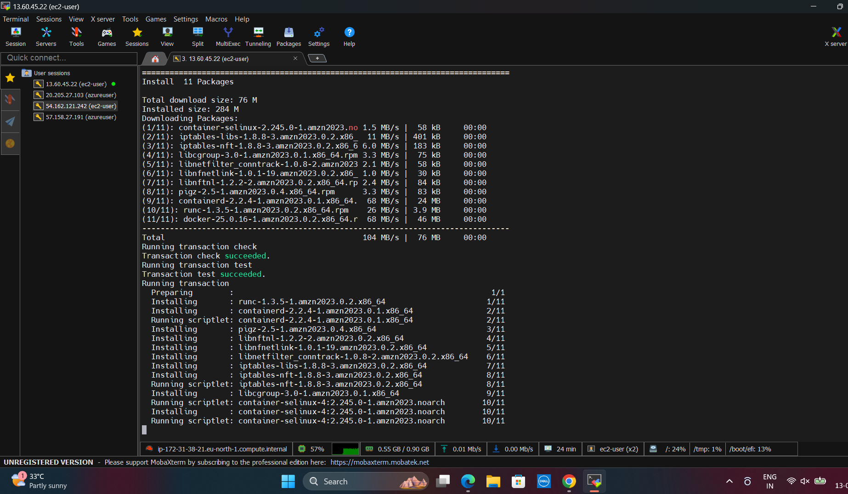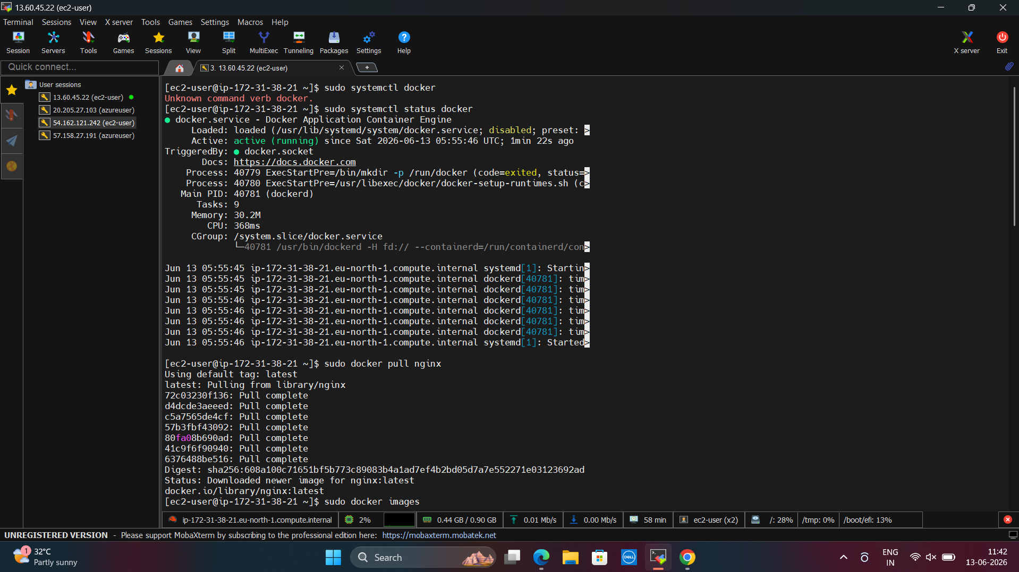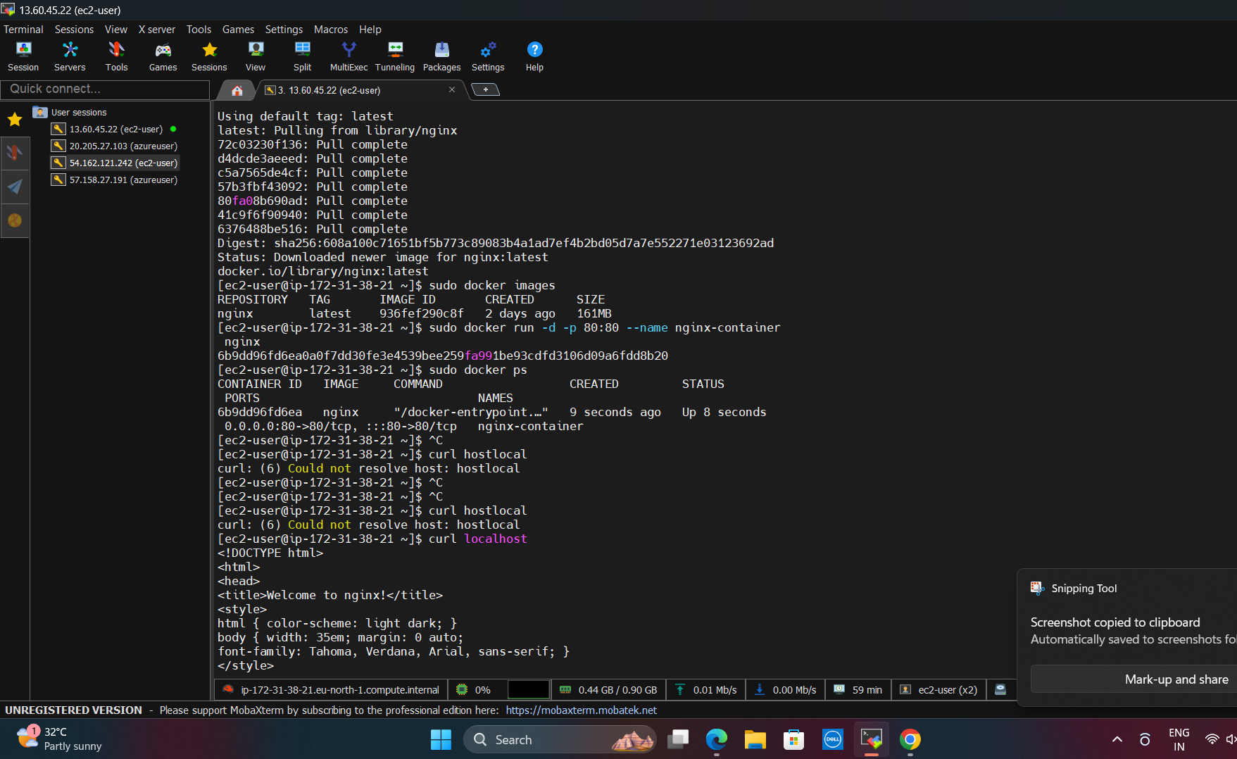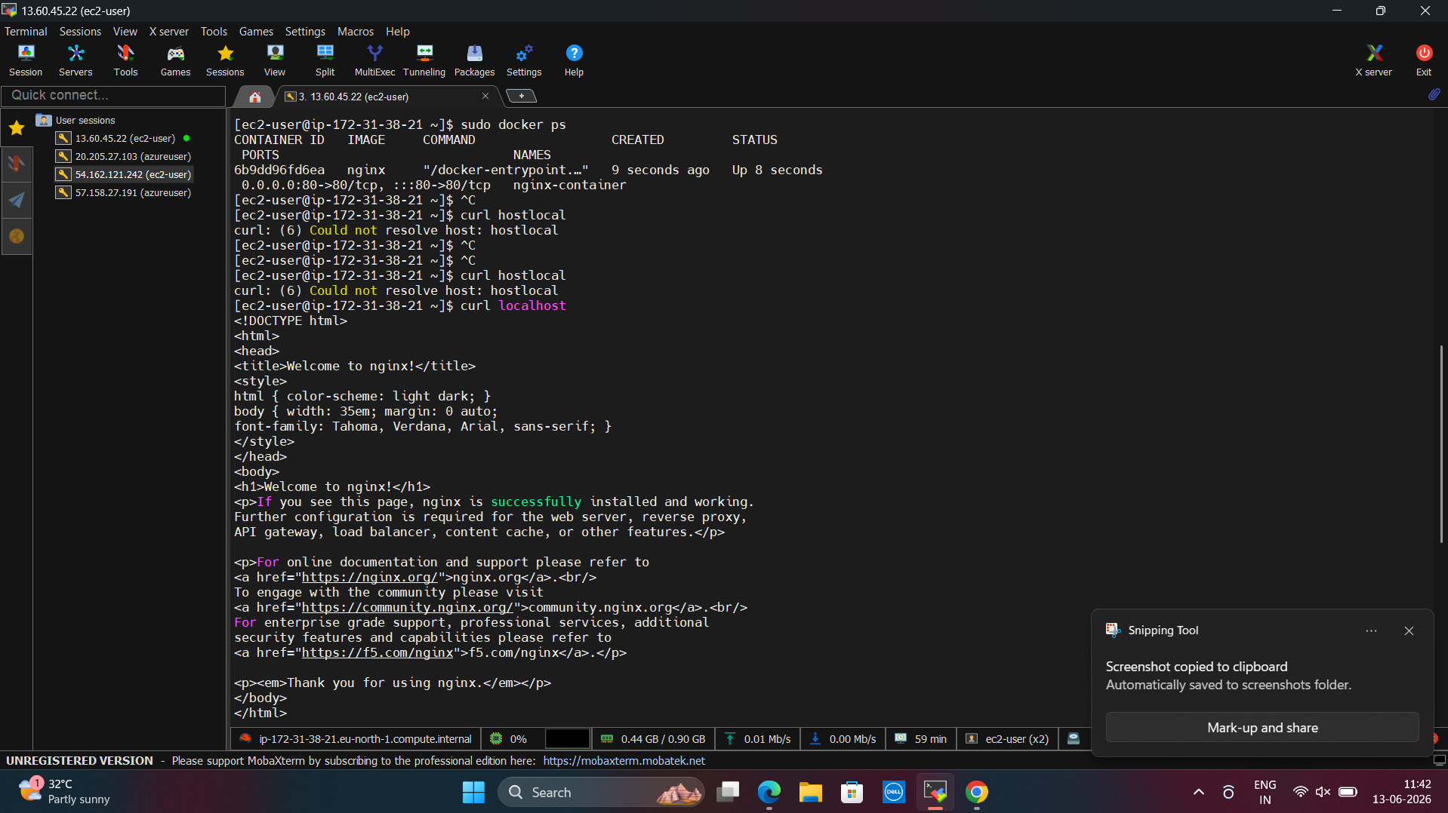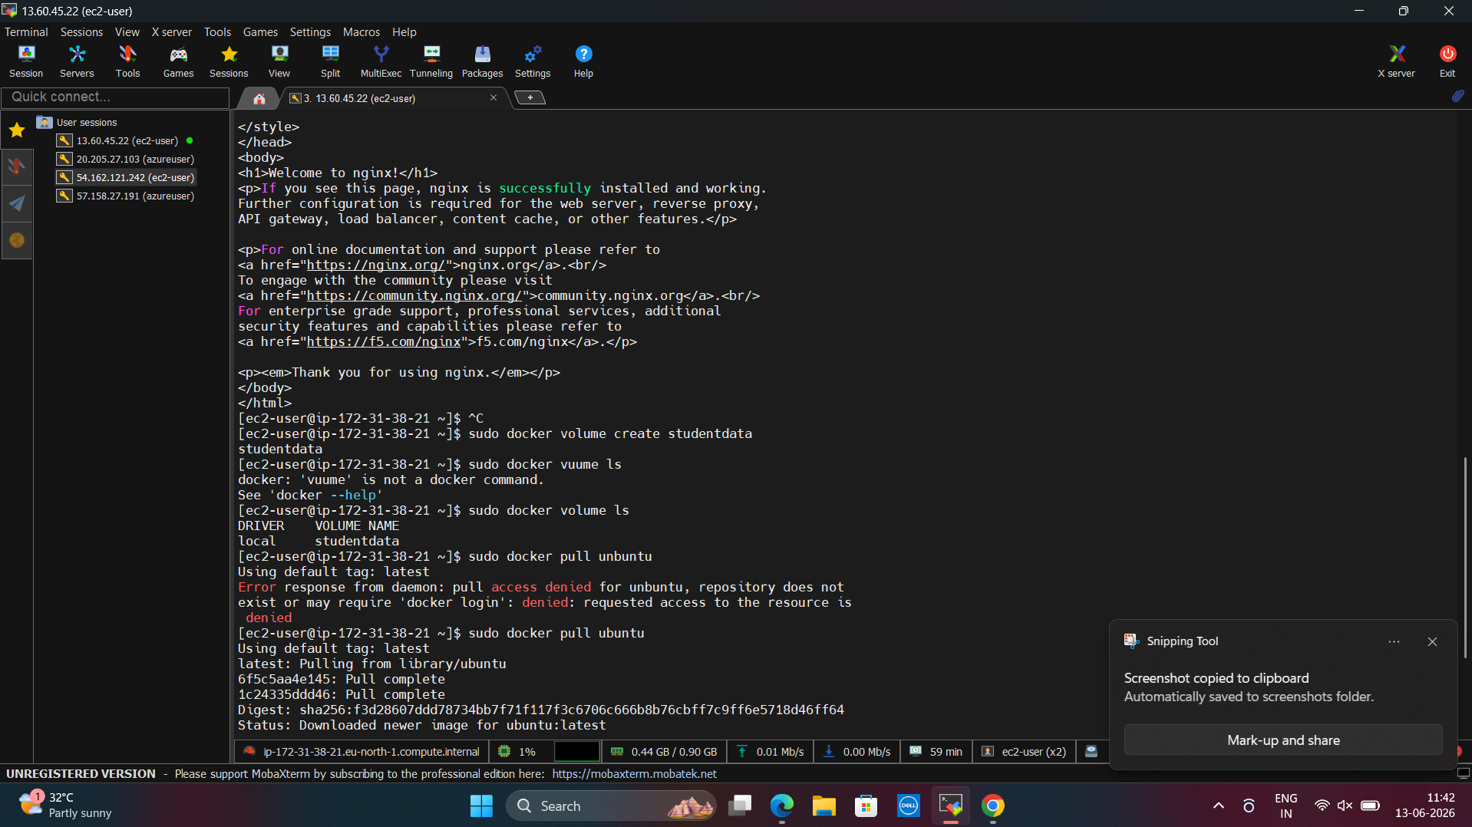
Q2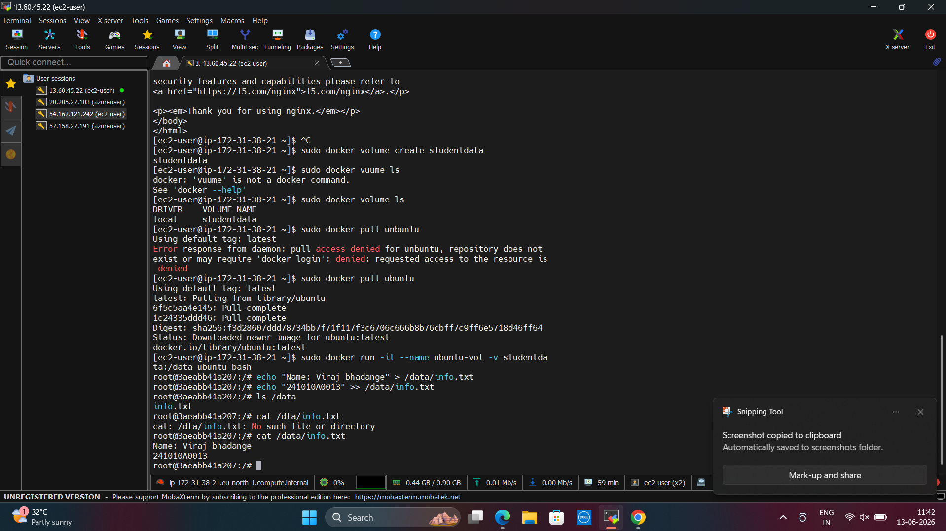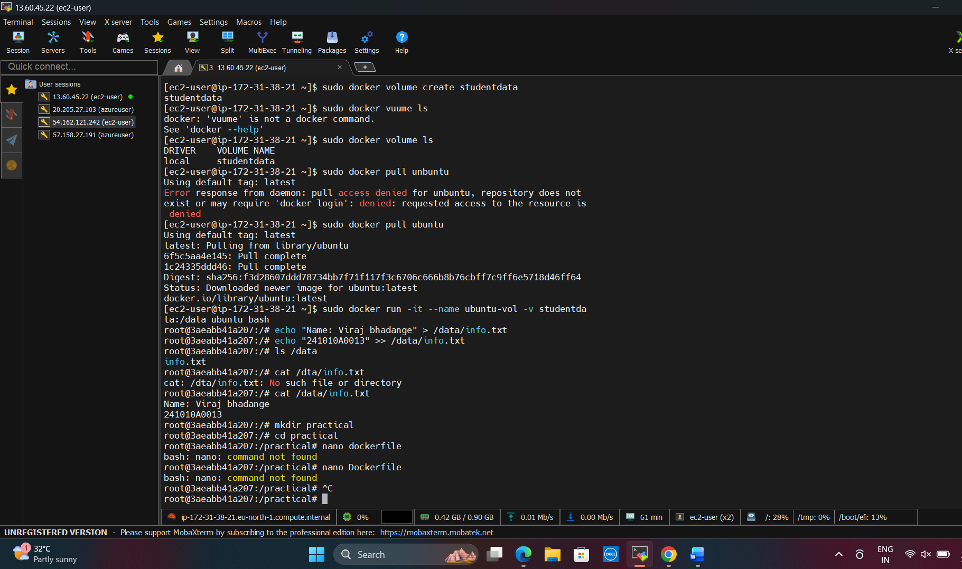
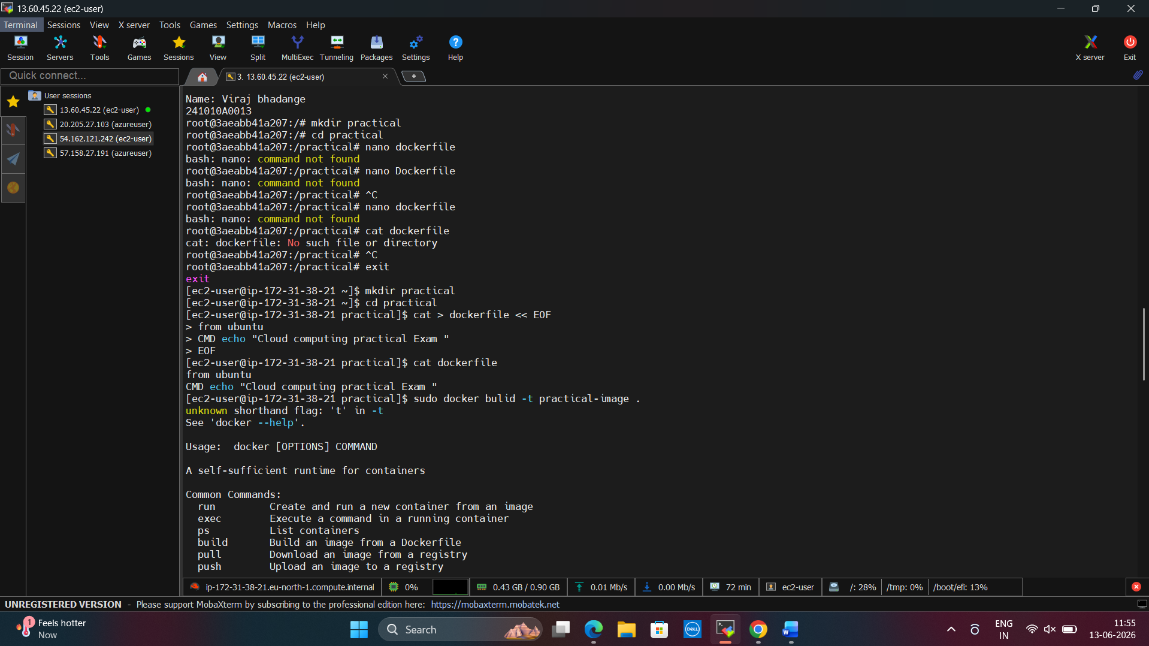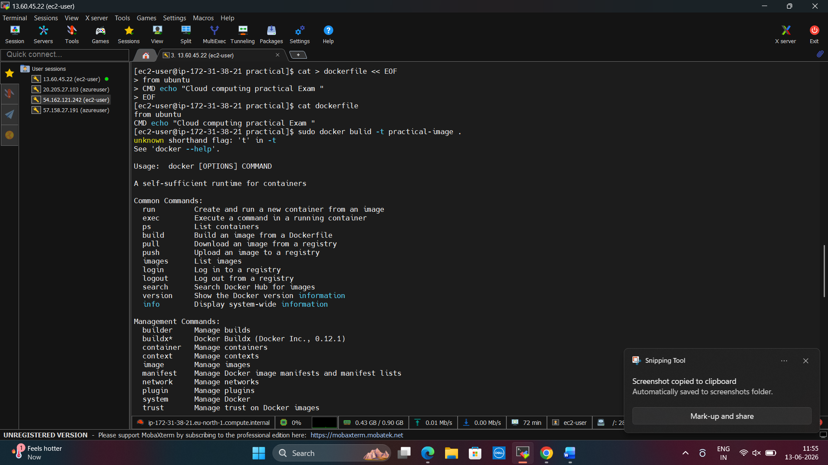
Q3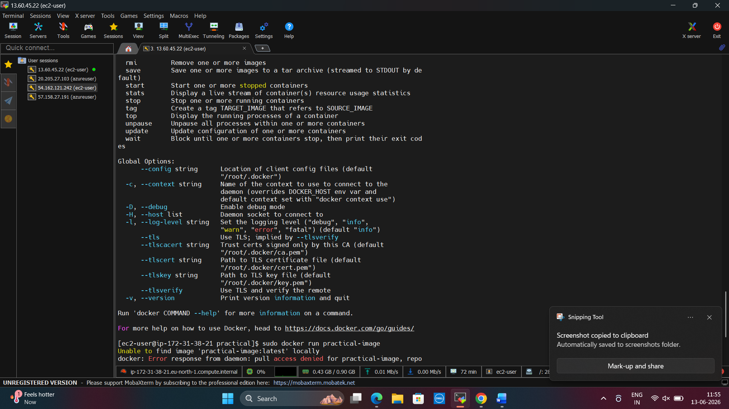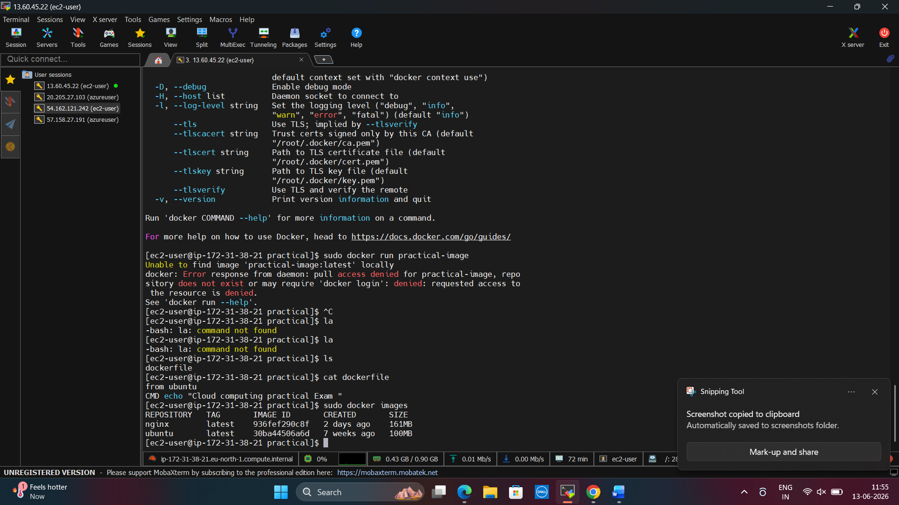

Bonus Challenge (Optional)

1. Difference between a Docker Image and a Docker Container
- A Docker Image is a read-only template that contains the application, libraries, and dependencies needed to run software.
- A Docker Container is a running instance of a Docker image. Containers can be started, stopped, and modified while running.
2. Why are Docker Volumes used?
- Docker Volumes are used to store data permanently outside the container.
- They help preserve data even if a container is deleted and allow data sharing between multiple containers.

